**RANK** = B0(Constant) + B1*height + B2*weight + B3*England + ~~B4*Japan~~ + B5*France + B6*Australia + B7*Egypt + B8*India + B9*Argentina + B10*USA + B11*hours_per_day + B12*strength + B13*agility + B14*mental

**Analytical Questions:**

1. Does "agility" affect a player's "rank"? Are players with higher agility more likely to have a better rank?
2. Does "nationality" influence a player's "rank"? Are there any significant differences in rank based on the player's nationality?
3. Does the "gender" of a player impact their "rank"? Are there significant differences in rank between male and female players?

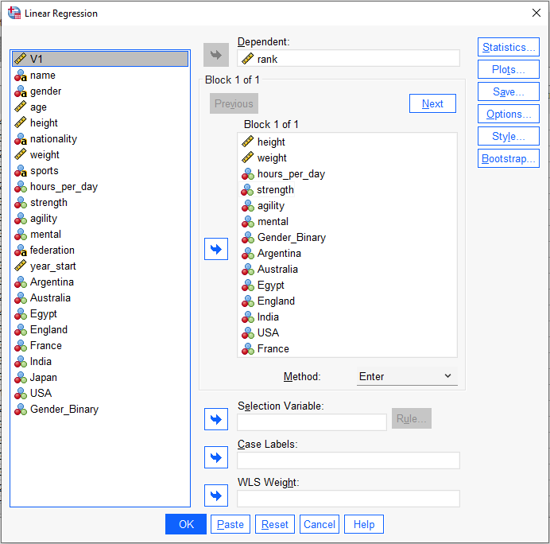

Presentation Work:



